Avipsa Bal
25BAI10360

Real-Time Stock Market Visualization and Prediction Tool
Introduction

- Stock Trend Analyzer is a Python desktop tool for visualizing, analyzing, and predicting stock market shifts.
- The application is targeted at individual investors and students who want quick insights into stock performance.
- Offers a clean, user-friendly interface for both beginners and intermediate users.
- Utilizes open-source data and libraries for transparency and reproducibility.
- Allows side-by-side comparison of major stocks and indices for data-driven decision making.

Problem Statement
- Traditional stock analysis tools are often complex, expensive, or unintuitive for new users.
- Most retail investors do not have easy access to simple, predictive analytics.
- Visual, actionable insights for popular stocks are lacking in free/open-source tools.
- Difficulties in comparing multiple stocks efficiently.
- There is a need for a zero-cost, educational tool that fits an academic setting.

Functional Requirements
- Allow users to select from a list of popular stocks and indices (e.g., Apple , Tesla , S&P 500 ).
- Fetch and display real-time and historical stock data.
- Show line and moving average charts for selected stocks.
- Predict and display the next day’s closing price using regression.
- Provide a “Best Stocks” recommendation feature based on historical returns.
- Error handling for missing or failed data retrieval.
- Clear, readable dashboard with sidebar and tabs.

Non-functional Requirements
- Application starts in under 3 seconds.
- Updates data within 2 seconds after a stock is selected.
- Low memory and CPU usage; should work on entry-level computers.
- Intuitive layout with accessible buttons and labels.
- Minimal prerequisites—installable with a single command.
- Easy to modify and extend codebase.

System Architecture
- GUI Layer: Tkinter frames for sidebar navigation, tabbed interface for analysis/results.
- Data Layer: Data handling via yfinance, processed by pandas and numpy.
- Analytics Layer: Machine learning with scikit-learn for prediction.
- Visualization Layer: Matplotlib integration for charts within Tkinter window.
- No persistent data storage, ensuring privacy and low resource usage.

Design Diagrams

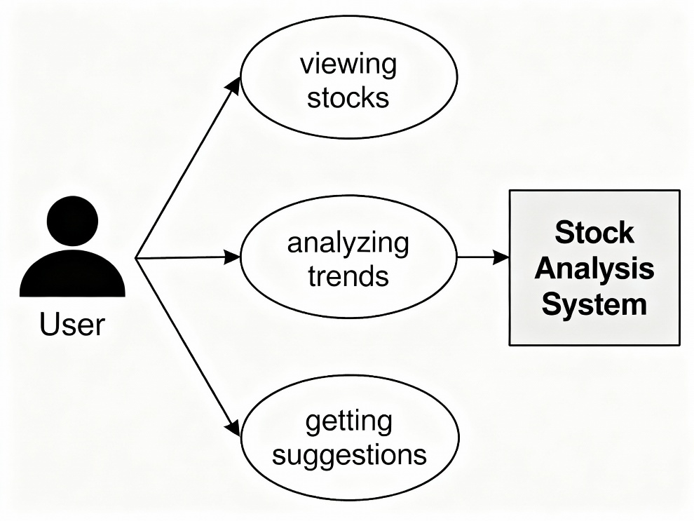
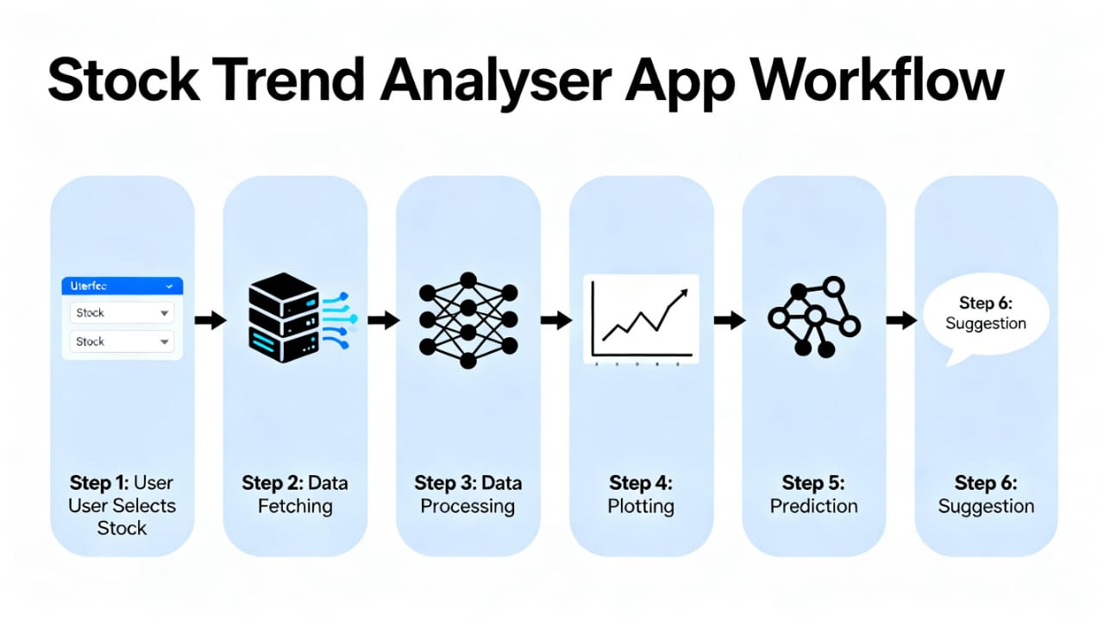
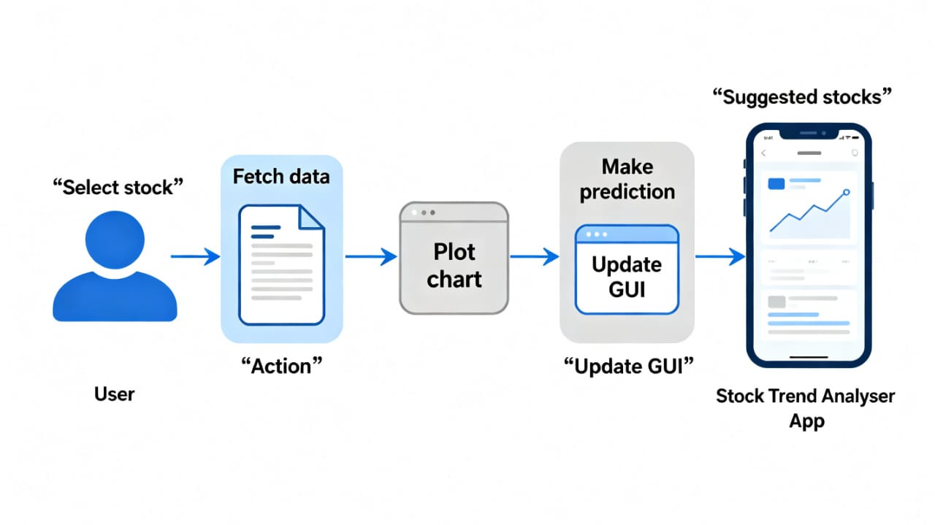

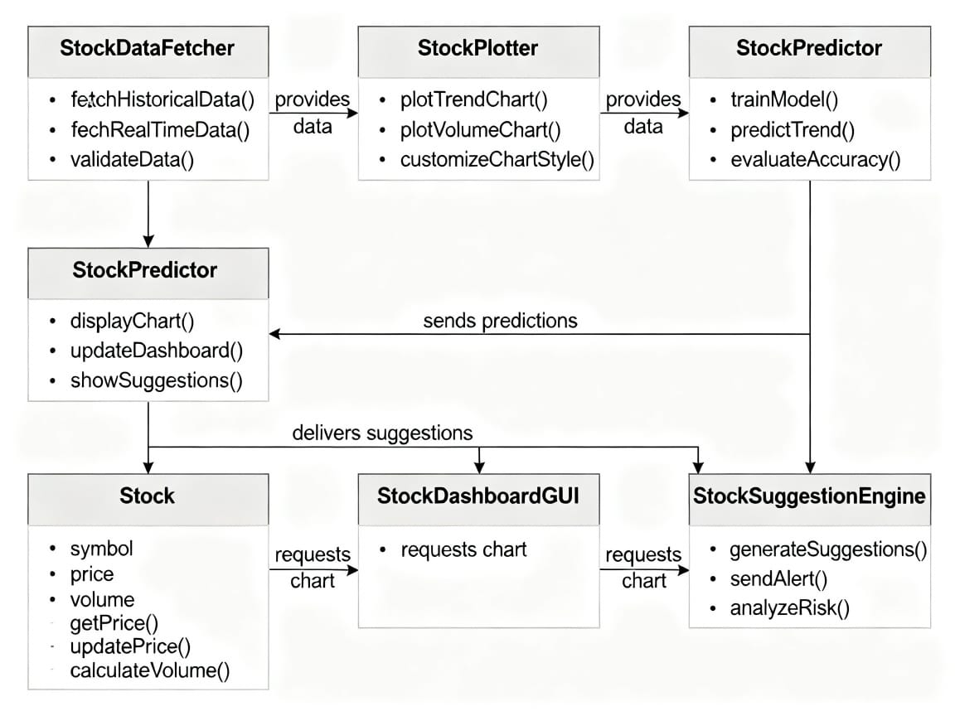
Design Decisions & Rationale
- Tkinter chosen for its cross-platform compatibility and zero install requirement.
- A dark mode interface for modern look and eye comfort.
- Lightweight libraries (e.g., yfinance) for fast, public data access.
- Machine learning (linear regression) chosen for simplicity and interpretability.
- Modular codebase to support future features.

Implementation Details
- Project structure separated by GUI, data, analysis, and result display functions.
- Code is fully commented and includes error/message dialogs for a smooth experience.
- Modular design: can add new analysis or visualizations with minimal code changes.
- No sensitive API keys or paid data—100% public and transparent

Screenshots / Results
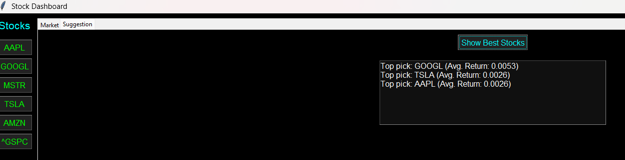

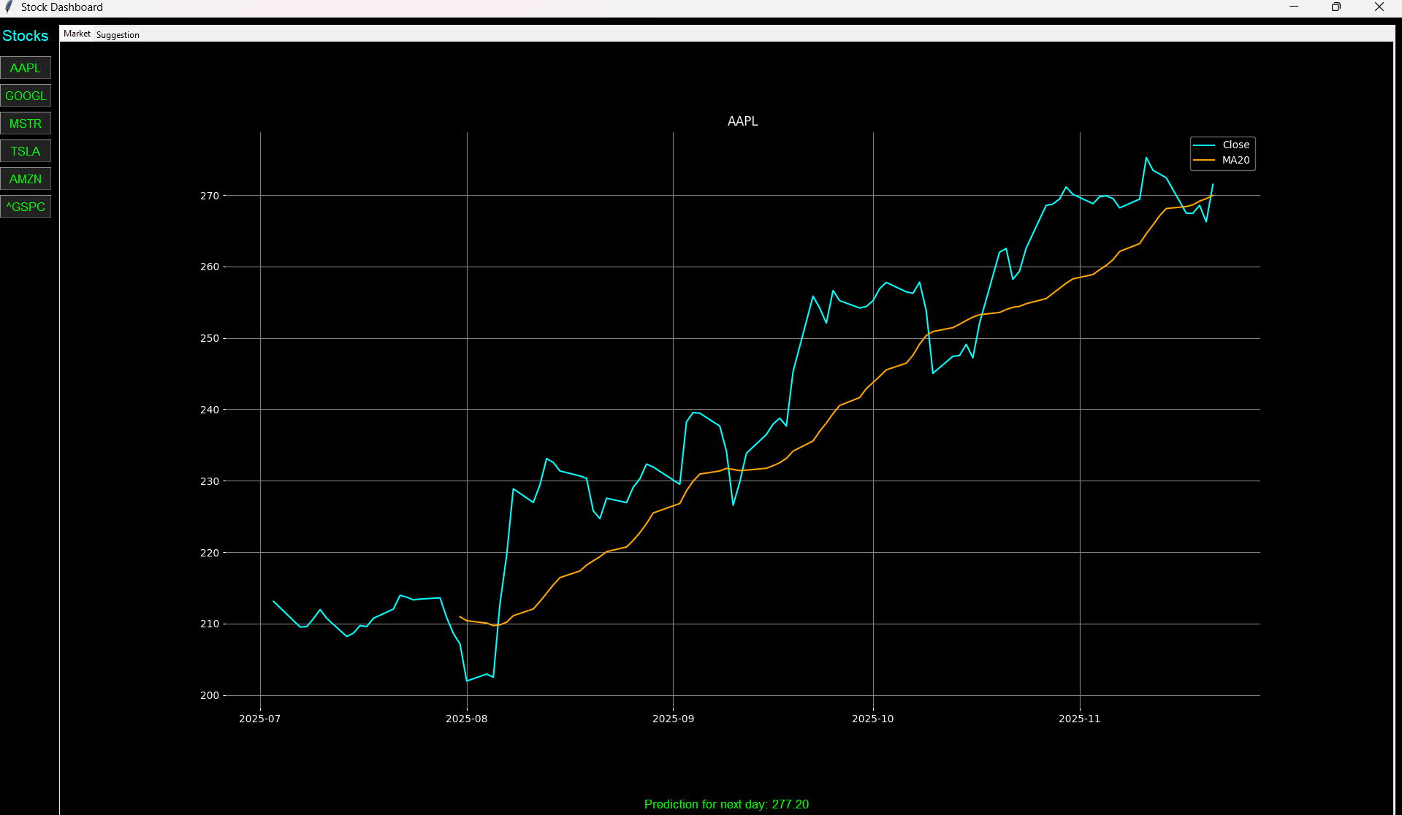

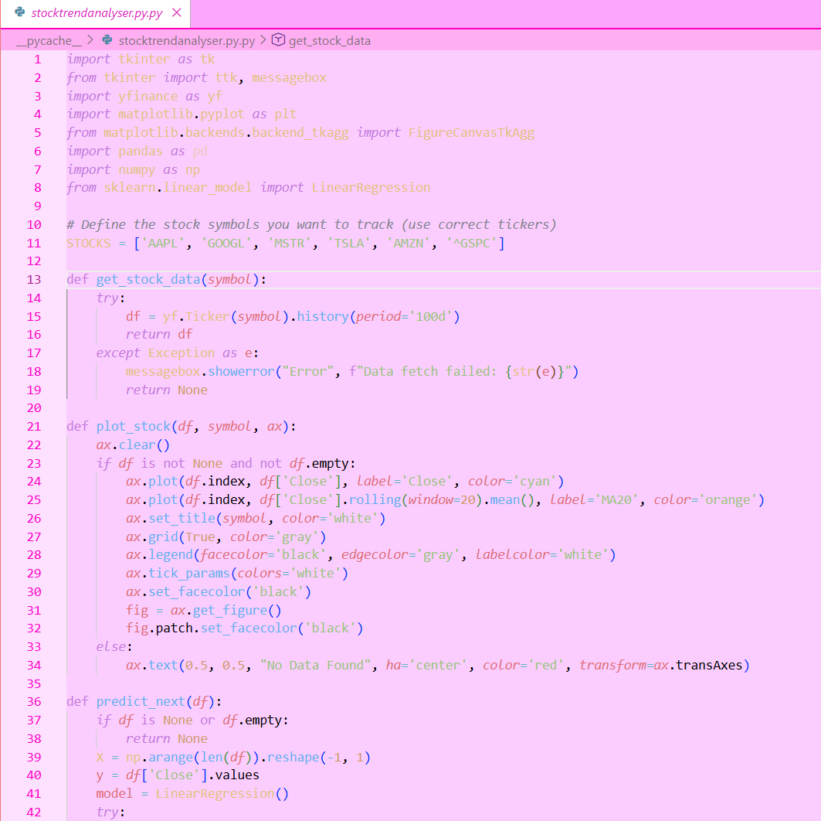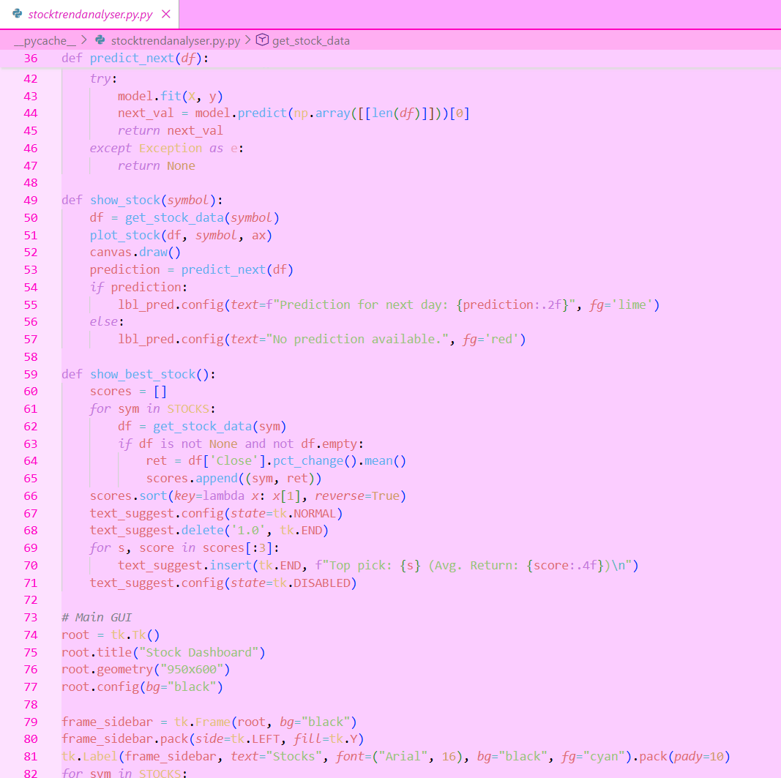
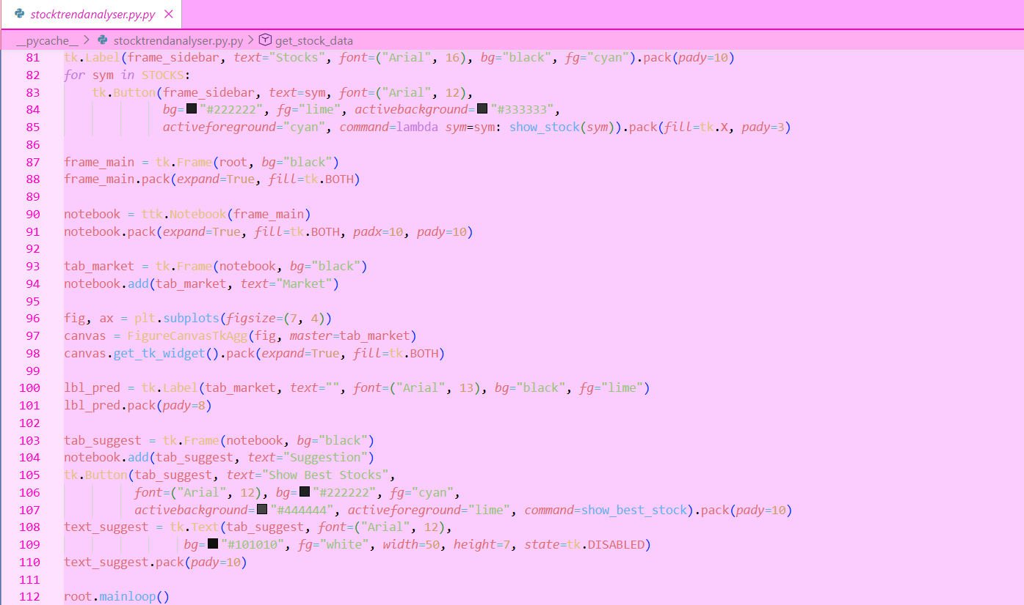

Testing Approach
- Manual user flow walkthroughs for all features.
- Simulated errors: wrong ticker, no internet, API limits.
- GUI responsiveness testing (no freezing).
- Cross-platform runs (Windows 10/11, MacOS, Linux).
- Checked accuracy of predictions with random historical samples.

Challenges Faced
- yfinance occasionally ratelimits; handled with pauses and user messages.
- Matplotlib integration in Tkinter required callback tweaking for redraws.
- Balancing simplicity vs. feature set (keeping UI uncluttered).
- Ensuring stability for users on slow internet or old laptops.

Learnings & Key Takeaways
- Hands-on experience with real financial APIs.
- Built confidence in Tkinter and structured Python programming.
- Improved debugging skills through real-world error handling.
- Understood importance of UI/UX in financial analysis tools.

Future Enhancements
- Enable search for any ticker, not just preset list.
- Add more machine learning models (random forests, LSTM, etc.).
- Portfolio feature for tracking multiple investments.
- Export results to CSV or PDF for reporting.
- Responsive web version for mobile/tablet use.

References
- yfinance GitHub repository and documentation
- Tkinter/tkdocs tutorial and examples
- matplotlib and scikit-learn user guides
- Official documentation for Python, pandas, numpy
- Resources on S&P 500 , Apple , Alphabet , Tesla , Amazon

